

**Green University of Bangladesh**

**Department of Computer Science and Engineering (CSE)**

**Faculty of Sciences and Engineering**

**Semester: (Spring, Year:2021), B.Sc. in CSE (Day/Eve)**

**Course Title:**

**Course Code: Section:**

**Lab Project Name: _ _ _ _ _ _ _ _ _ _ _ _ _ _ _ _ _ _ _ _ _ _ _ _ _ _ _ _**

**Student Details**

|  |  |  |
| --- | --- | --- |
| **Name** | | **ID** |
| **1.** |  |  |
| **2.** |  |  |
| **3.** |  |  |

**Submission Date : _ _ _ _ _ _ _ _ _ _ _ _ _ _ _ _ _ _ _ _ _ _ _ _**

**Course Teacher’s Name : _ _ _ _ _ _ _ _ _ _ _ _ _ _ _ _ _ _ _ _ _ _ _ _**

**[For Teachers use only: Don’t Write Anything inside this box]**

|  |
| --- |
| **Lab Project Status**  **Marks: ………………………………… Signature: .....................**  **Comments: .............................................. Date: ..............................** |

Table of Contents

Chapter 1 Introduction 3

1.1 Introduction 3

1.2 Design Goals/Objective 3

Chapter 2 Design/Development/Implementation of the Project 4

2.1 Section (Choose the name of this section as appropriate with your project) 4

2.2 Section (Choose the name of this section as appropriate with your project) 4

2.2.1 Subsection 4

Chapter 3 Performance Evaluation 5

3.1 Simulation Environment/ Simulation Procedure 5

3.2 Results and Discussions 5

Chapter 4 Conclusion 6

4.1 Introduction 6

4.1 Practical Implications 6

4.2 Scope of Future Work 6

References 7

# Chapter 1 Introduction

## Introduction

Start the section with a general discussion of the project.

## Design Goals/Objective

Specify and discuss the goals of your project.

# Chapter 2

# Design/Development/Implementation of the Project

## Section (Choose the name of this section as appropriate with your project)

These are only examples of how one can add as many as sections and subsections needed according to the topic.

* + 1. **Subsection**



Figure 2.1: Figure name

## Section (Choose the name of this section as appropriate with your project)

## Subsection

# Chapter 3 Performance Evaluation

## Simulation Environment/ Simulation Procedure

Discuss experimental set up and environment installation needed for the simulation of your outcomes.

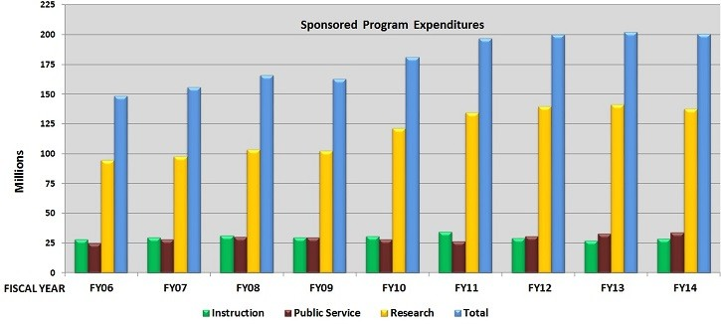

Figure 3.1: Name of figure

## Results and Discussions

* + 1. **Results**
    2. **Analysis and Outcome**

# Chapter 4 Conclusion

## Introduction

Discuss the contents of this chapter and summarized description of the work and the results and observation. Generally, it should be in one paragraph.

## Practical Implications

Discuss the practical implications of the project…

## Scope of Future Work

Discuss the future work of the project...

# References

1. Author Initial. Author Surname, Title. City: Publisher, Year Published, p. Pages Used.
2. A. Rezi and M. Allam, ”Techniques in array processing by means of transforma- tions, ” in Control and Dynamic Systems, Vol. 69, Multidemsional Systems, C. T. Leondes, Ed. San Diego: Academic Press, 1995, pp. 133-180.
3. O. B. R. Strimpel, ”Computer graphics,” in McGraw-Hill Encyclopedia of Science and Technology, 8th ed., Vol. 4. New York: McGraw-Hill, 1997, pp. 279-283.
4. K. Schwalbe, Information Technology Project Management, 3rd ed. Boston: Course Technology, 2004.
5. M. N. DeMers, Fundamentals of Geographic Information Systems, 3rd ed. New York: John Wiley, 2005.
6. M. Bell, et al., Universities Online: A survey of online education and services in Australia, Occasional Paper Series 02-A. Canberra: Department of Education, Science and Training, 2002.